ROSHAN TAPAS BASU

15BCE0837

PARALLEL ADDER

1)

Truth table 2 BIT ADDER

A1 a2 b1 b2 cout s1 s2

00 0 0 000  
00 01      001  
00 10      010  
00 1 1      011  
01 00      001  
01 01      010  
01 10      011  
01  11      100  
11  00     011  
10 01      011  
10 10     100  
10 11      101  
11 00      011  
11 01      100  
11 10      101  
11 11       110

TRUTH TABLE FOR 2 BIT SUBTRACTOR

A1 A0 B1 B0 COUT D1 D0   
  
0 0 0 0 0 0 0   
0 0 0 1 1 0 1   
0 0 1 0 1 1 0   
0 0 1 1 1 1 1   
0 1 0 0 0 0 1   
0 1 0 1 0 0 0   
0 1 1 0 1 0 1   
0 1 1 1 1 1 0   
1 0 0 0 0 1 0   
1 0 0 1 0 0 1   
1 0 1 0 0 0 0   
1 0 1 1 1 0 1   
1 1 0 0 0 1 1   
1 1 0 1 0 1 0   
1 1 1 0 0 0 1   
1 1 1 1 0 0 0 

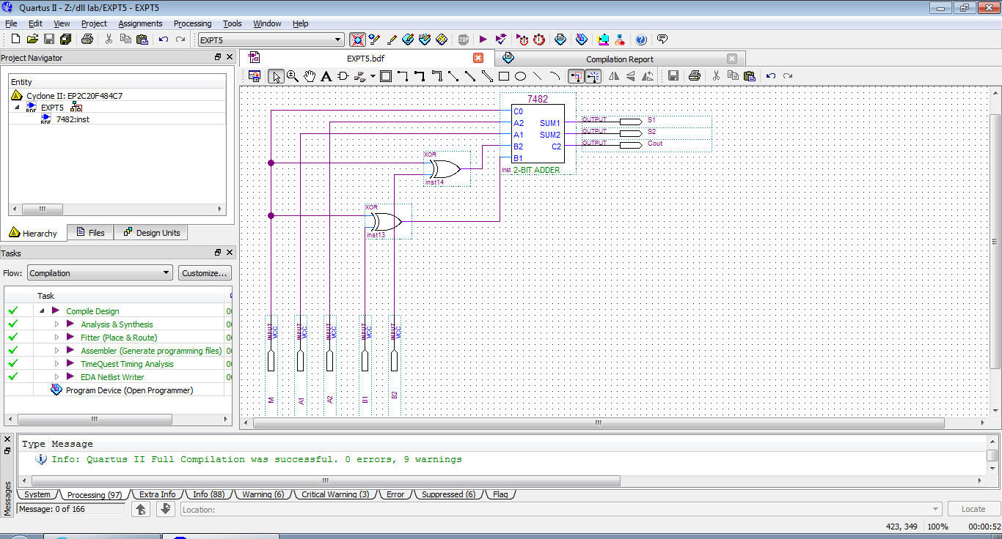

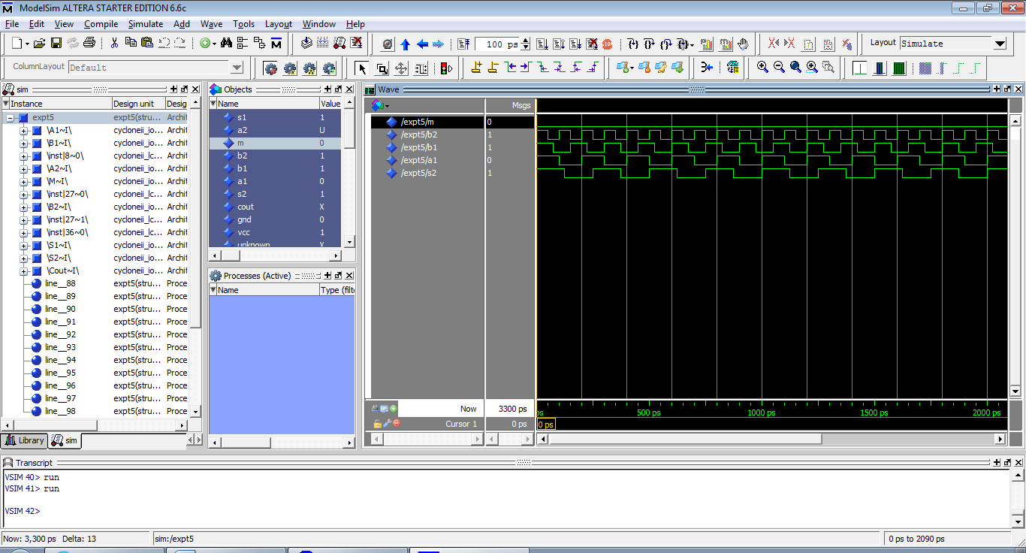

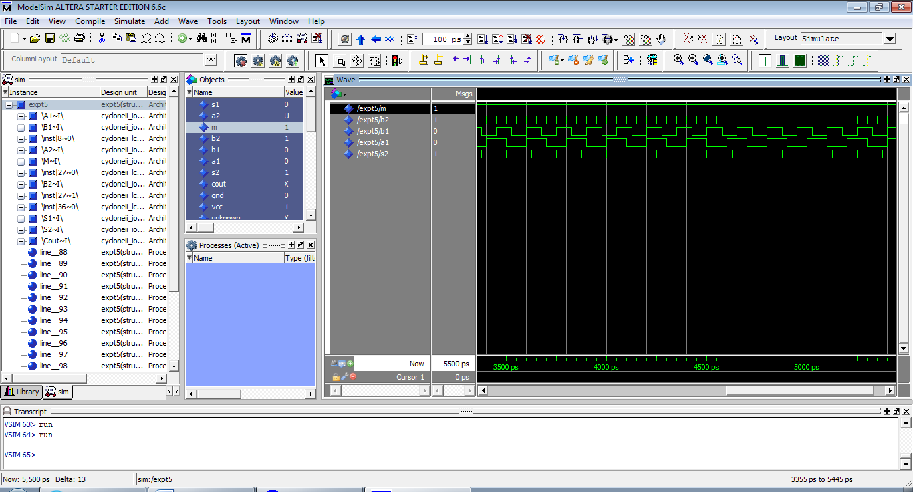

2)

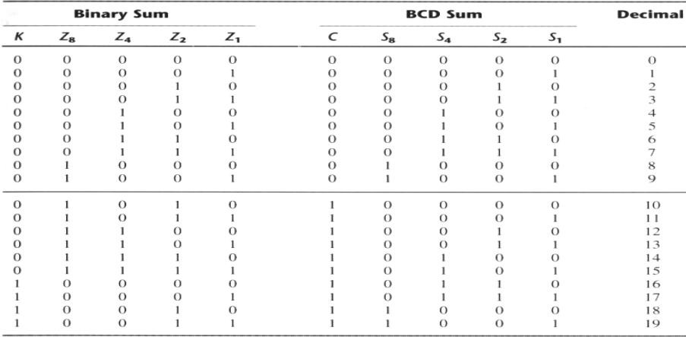

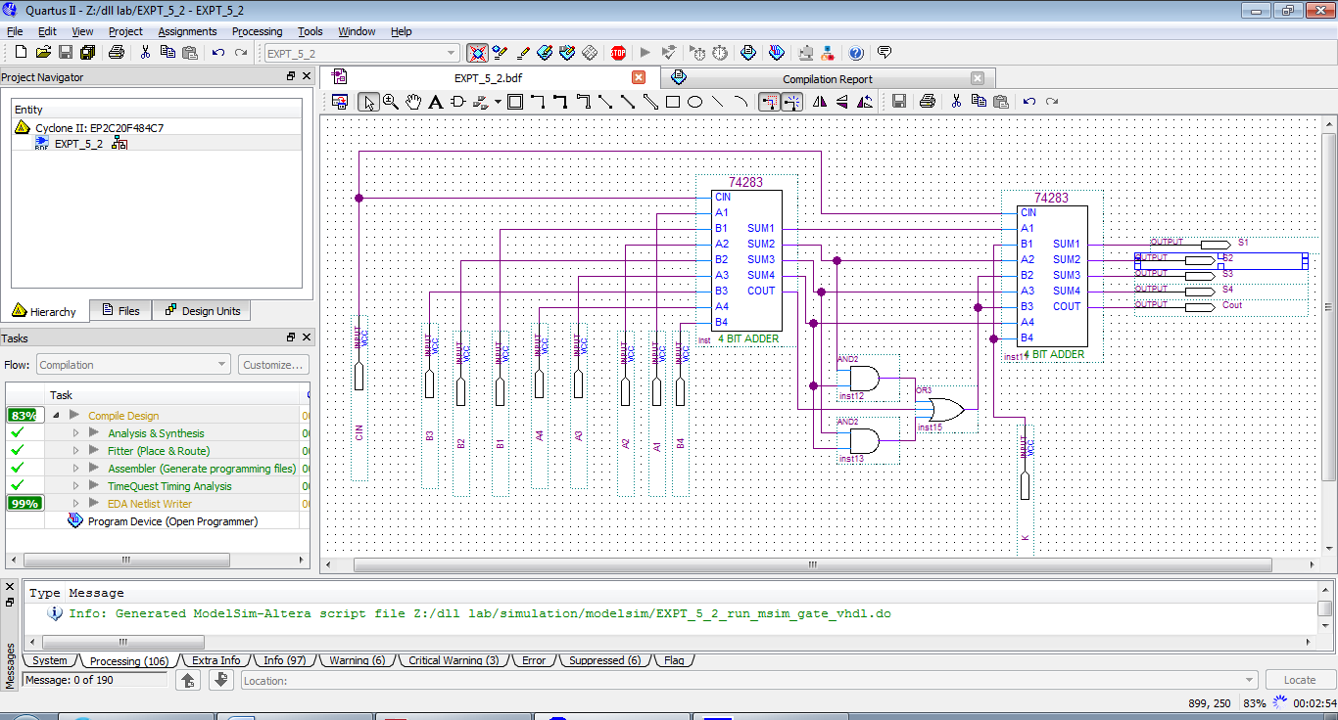

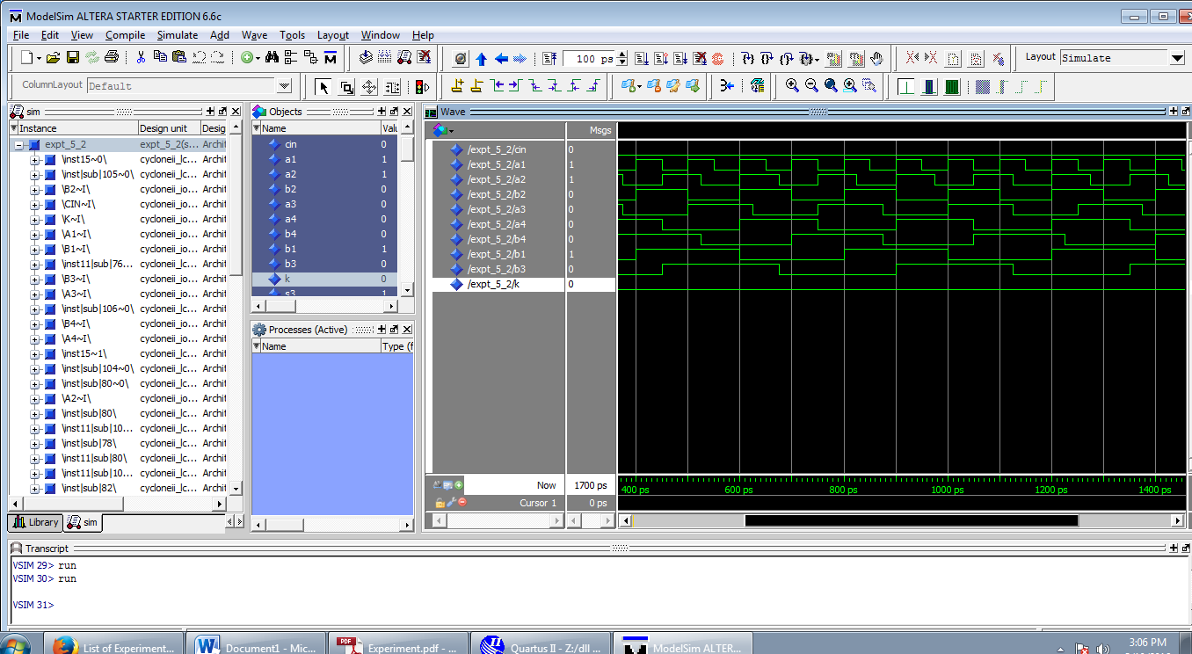

4)

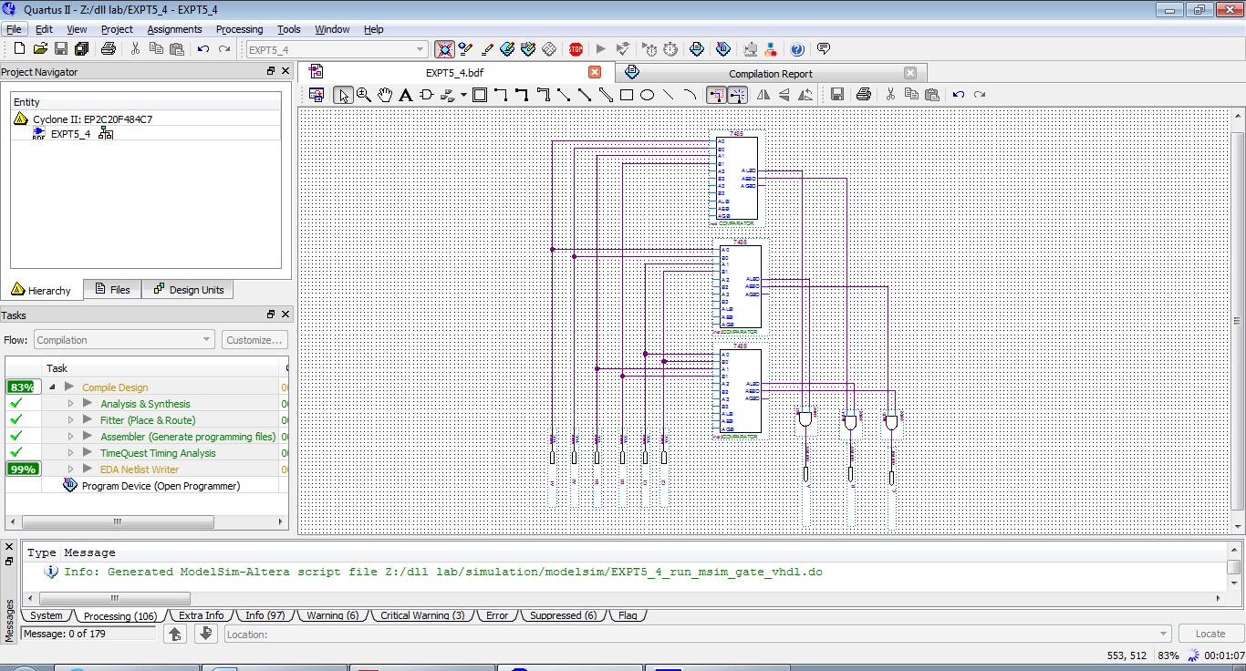

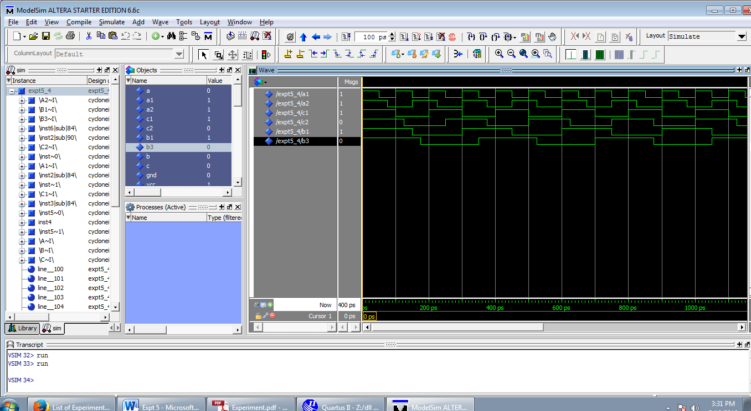

TRUTH TABLE:

A0 A1 B0 B1 C0 C1 A B C

1 1 0 0 1 0 1 0 0

1 1 1 0 0 1 1 0 0

1 1 0 0 0 1 1 0 0

1 1 1 0 0 0 1 0 0

1 1 0 1 0 0 1 0 0

1 1 0 1 1 0 1 0 0

1 1 0 0 0 0 1 0 0

1 1 0 1 0 1 1 0 0

1 1 1 0 1 0 1 0 0

0 0 1 1 1 0 0 1 0

0 0 1 1 0 1 0 1 0

0 0 1 1 0 0 0 1 0

0 1 1 1 0 0 0 1 0

0 1 1 1 0 1 0 1 0

0 1 1 1 1 0 0 1 0

1 0 1 1 0 0 0 1 0

1 0 1 1 0 1 0 1 0

1 0 1 1 1 0 0 1 0

0 0 0 0 1 1 0 0 1

0 0 0 1 1 1 0 0 1

0 0 1 0 1 1 0 0 1

0 1 0 0 1 1 0 0 1

0 1 0 1 1 1 0 0 1

0 1 1 0 1 1 0 0 1

1 0 0 0 1 1 0 0 1

1 0 0 1 1 1 0 0 1

1 0 1 0 1 1 0 0 1

1 0 0 0 0 1 1 0 0

1 0 0 1 0 0 1 0 0

0 0 1 0 0 1 0 1 0

0 1 1 0 0 0 0 1 0

0 0 0 1 1 0 0 0 1

0 1 0 0 1 0 0 0 1